PRISCILLA WANJIKU
BBIT/2023/72533
BACHELOR OF BUSINESS AND INFORMATION TECHNOLOGY
BIT3208
ADVANCED WEB DESIGN AND DEVELOPMENT
MR. MICHAEL NYORO
MAY/AUGUST 2026

Kikapu Mart Ecommerce Website
Selected technologies- HTML, CSS, Javascript,PHP+MySQL
https://github.com/wanjiku2004/Advanced-web-design-project GitHub repository link

Table of Contents

Table of Contents
Table of Contents 2
Week 1: Local Environment Setup 3
Title 3
Required Evidence 3
Reflection 5
Week 2: Wireframe and GUI Design 6
Reflection 6
Week 3: JavaScript and PHP Basics 7
Title 7
Reflection: 8
Week 4: Introduce Dynamic Backend Processing and Real User Interaction Systems 9
Reflection: 11
Week 5: Building Data-Driven Systems Using Databases 12
CRUD Operations and SQL Query 12
Week 6: Database Integration and CRUD Operations 16
Practical Task 1: Student Management System 16
Practical Task 2: Library Management System 18
Practical Task 3: Employee Management System 20

-8+

Week 1: Local Environment Setup

Title
Installation and Testing of Local Development Environment

Required Evidence
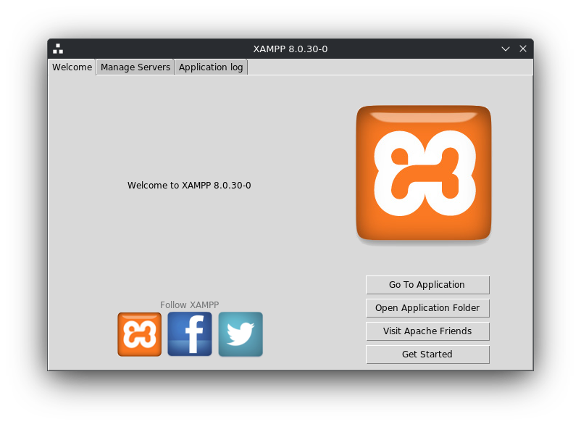Figure 1: Installation of Xampp

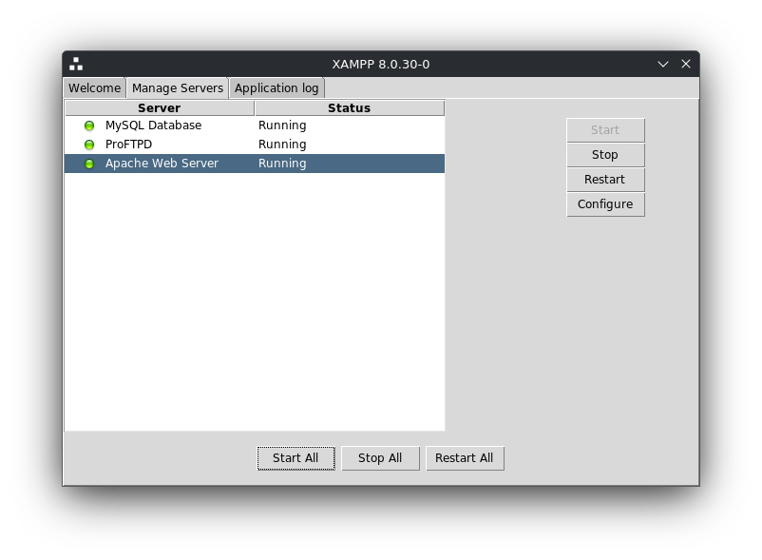Figure 2: Apache and MySQL Running

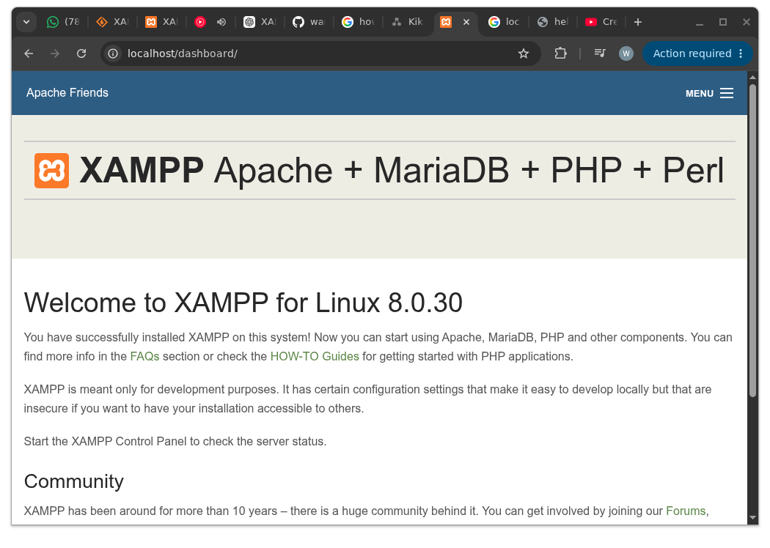Figure 3: Localhost Test Page

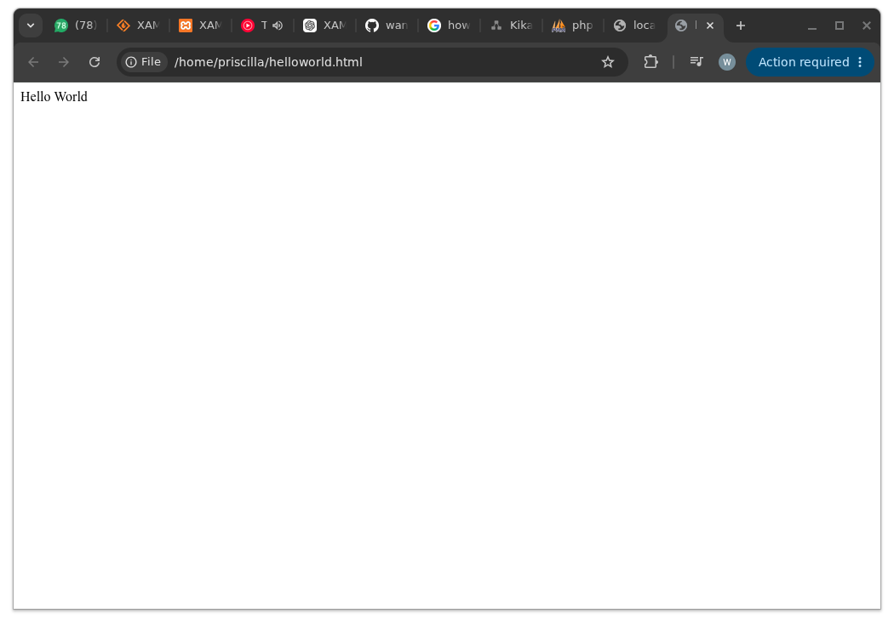Figure 4: Hello World Test

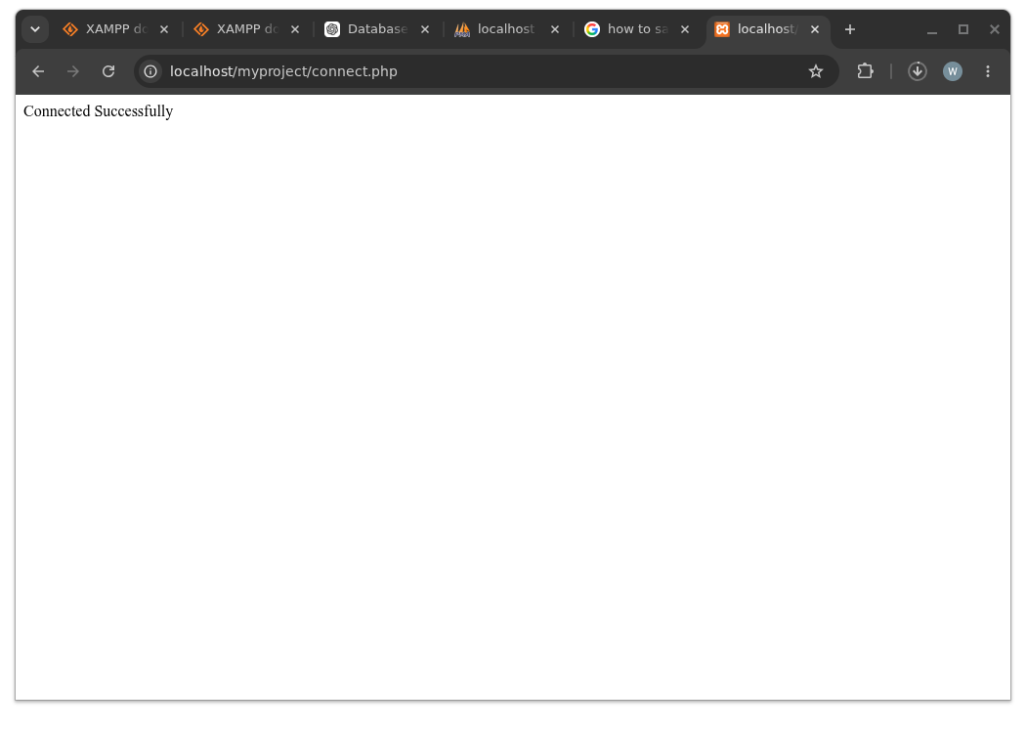Figure 5: Database Connection Test

Reflection
- I have learned how to install Xampp and run Apache and MySQL. I also learned how to run a localhost test page, a html page and how to do a successful database connection.
- The technologies I used were html and MySQL+PHP
- I encountered a challenge in disabling apache2 but I was able to do so and enable apache
- Screenshots:
- Fig.1 shows that Xampp was installed successfully in my computer
- Fig.2 shows that apache and MySQL were running successfully after installation of Xampp
- Fig.3 shows the browser running localhost. This explains that apache was working.
- Fig.4 shows that “Hello World” was displayed on the browser after using html to write the code.
- Fig.5 shows successful connection between PHP and MySQL using mysql_connect(). This confirmed that apache and MySQL services were properly configured in Xampp.

Week 2: Wireframe and GUI Design

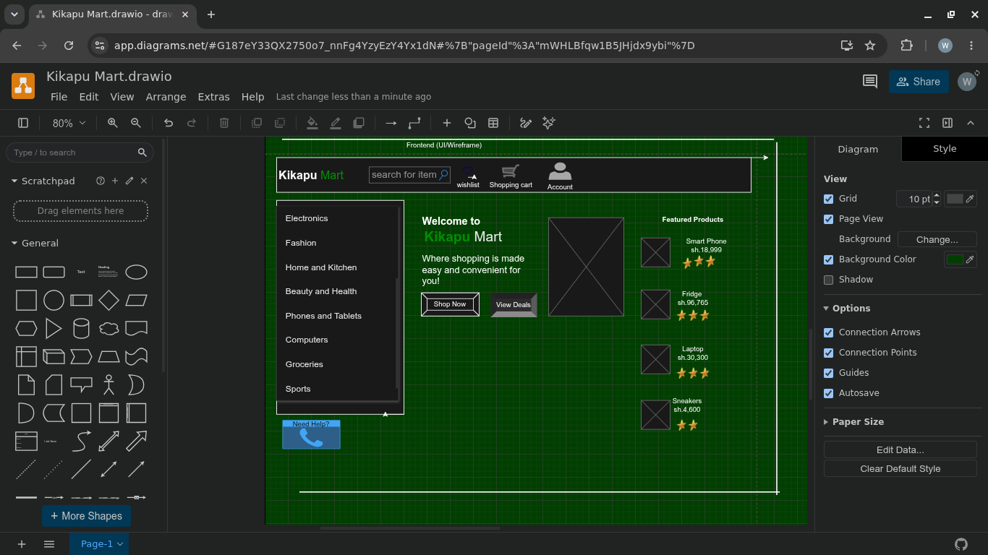Figure 6: Wireframe and GUI Design

Reflection
- Why the design was selected:
The design was selected because it provides a simple, organized, and user-friendly e-commerce layout. It highlights key features such as product categories, featured products, search functionality, shopping cart, wishlist, and user accounts, making online shopping efficient and accessible.
- User Experience Considerations:
The interface uses a clear structure, visible product categories, quick-access icons, and call-to-action buttons to reduce user effort and improve usability.
- Navigation Flow Planning:
Users can search for products, browse categories, view featured items, add products to the cart or wishlist, and manage their accounts through a logical top-to-bottom navigation flow.
- Intended System Users:
Online shoppers, retail customers, store administrators, and product managers using Kikapu Mart for purchasing and managing products.

Week 3: JavaScript and PHP Basics

Title
Frontend Interaction and Backend Foundations

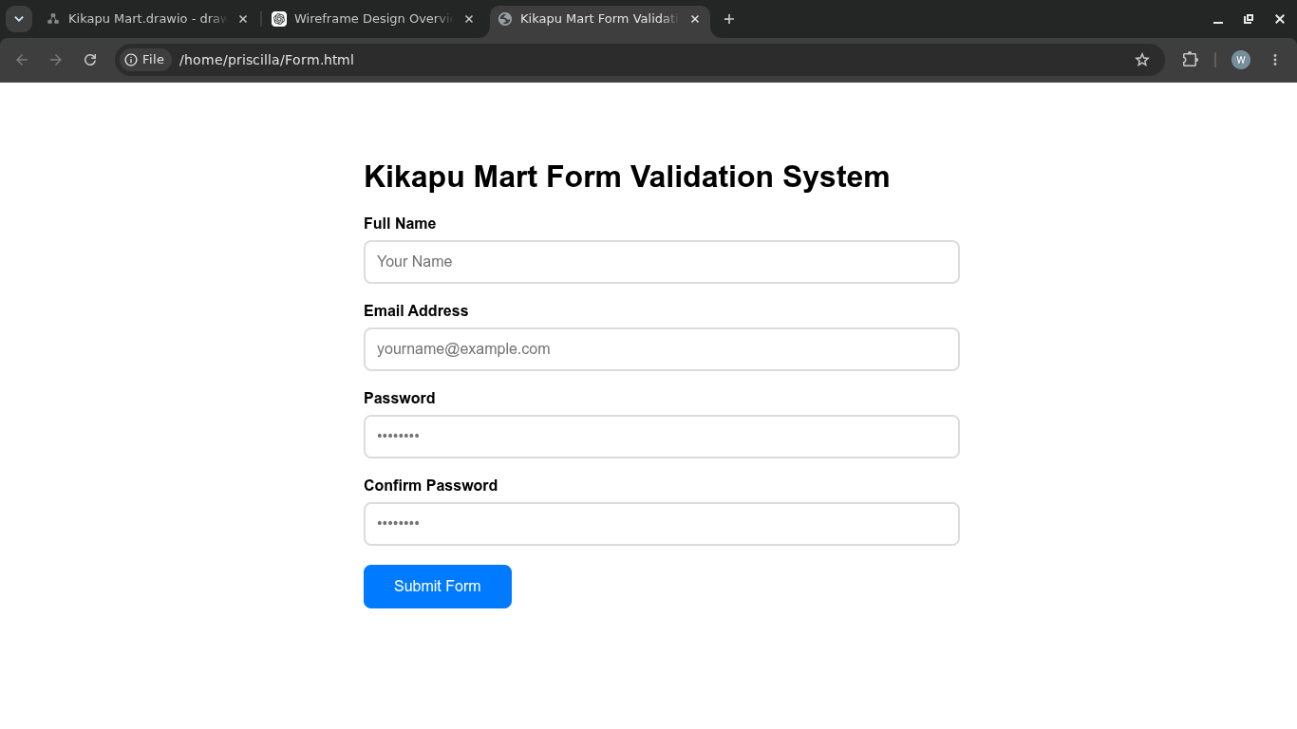Figure 7: JavaScript Form Validation
Figure 8: Database Connection

Reflection:
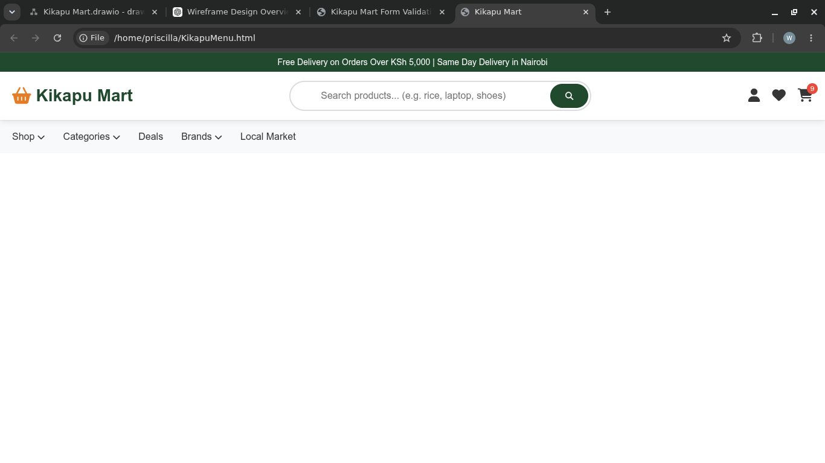Figure 9: Dynamic User Input Handling
- Fig.7 shows a form validation system created by javascript with a strength password checker
- Fig.8 shows a successful database connection. This explains that the apache and MySQL were working after PHP syntax practice.
- Fig.9:This image shows the homepage navigation interface of the Kikapu Mart e-commerce system. The layout is designed to provide users with quick access to products, promotions, and shopping features while maintaining a clean and user-friendly experience.

Frontend interfaces (like the Kikapu Mart menu and registration form) collect user data and send requests to the backend server via HTTP. The backend processes this logic and talks to the database to store or fetch information, sending the results back to the frontend.
- Validation Purpose: Frontend validation provides instant feedback, catching user errors (like mismatched passwords) before submission to improve UX and reduce server load.
- Database Connection: Essential for data persistence, allowing the backend to securely store registered users or dynamically retrieve products.
- Technologies: HTML/CSS (UI structure), JavaScript (validation), PHP (backend logic), and MySQL (database).

Week 4: Introduce Dynamic Backend Processing and Real User Interaction Systems
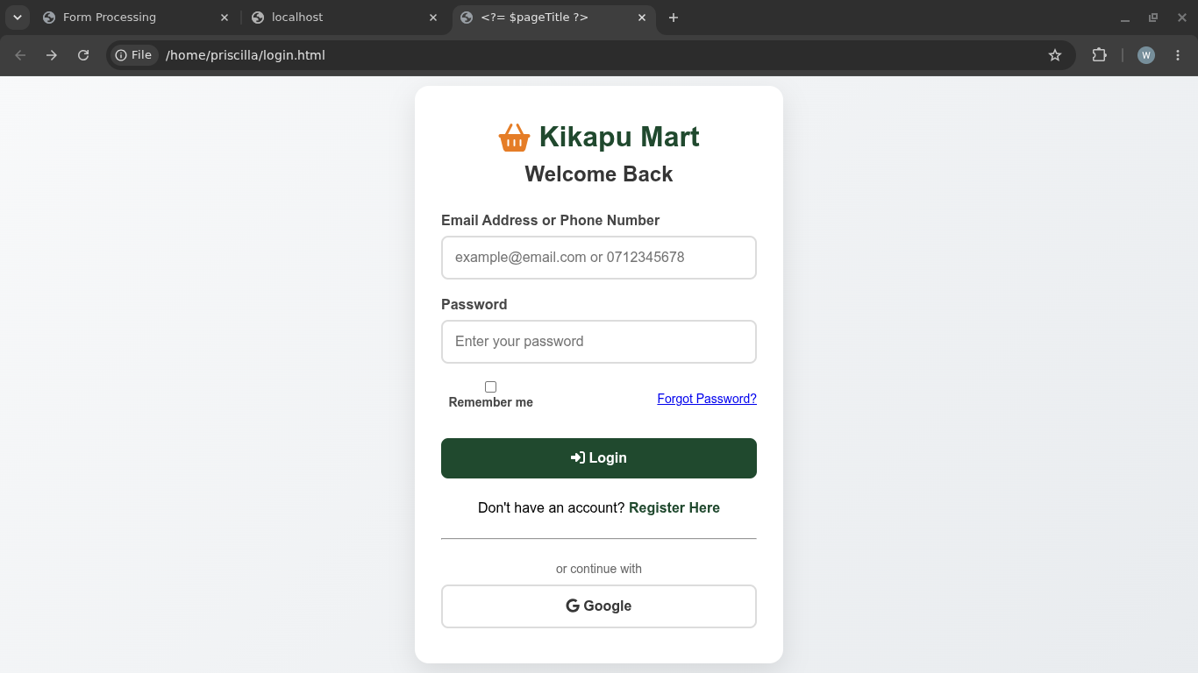Figure 10: Login Form

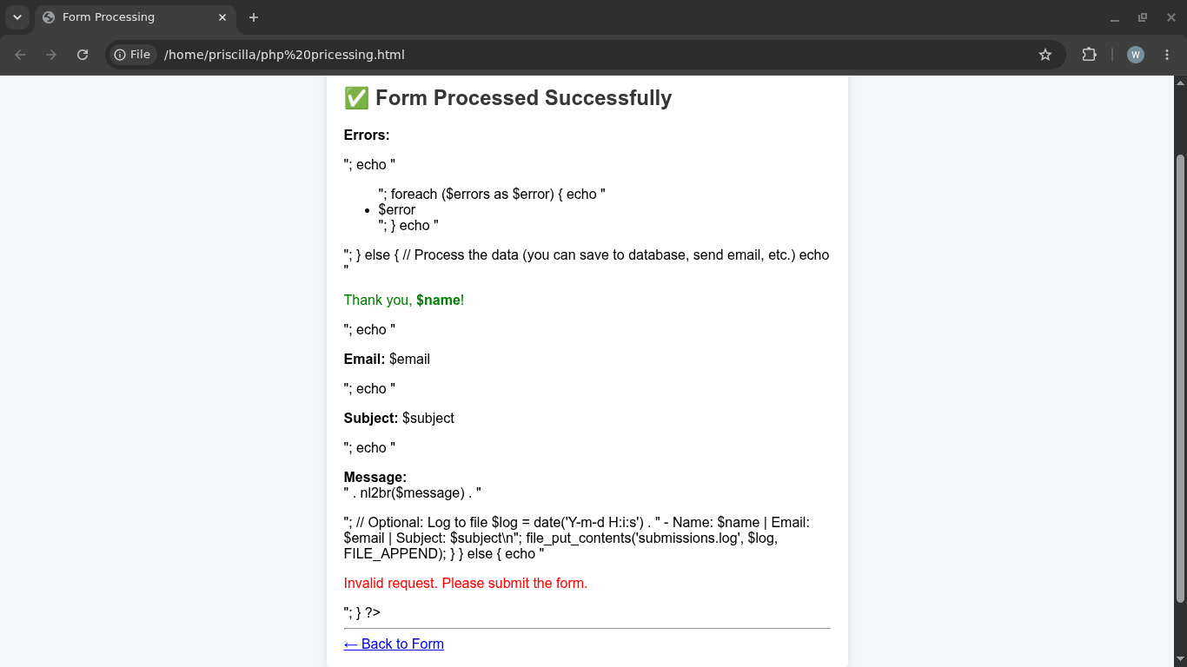Figure 11: PHP Processing

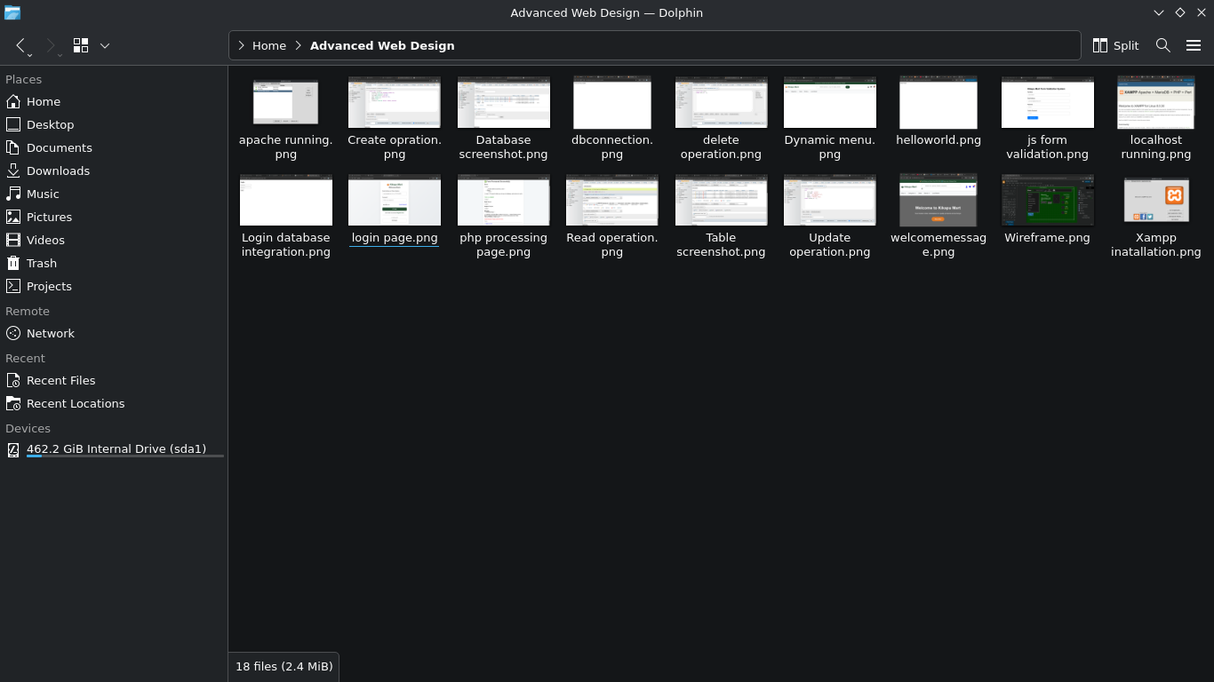Figure 12: Folder Structure

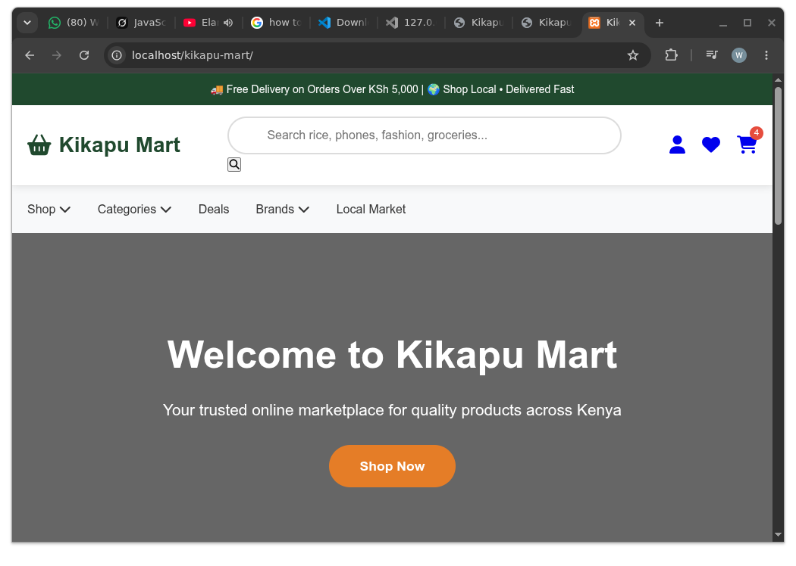Figure 13: Database Connection

Reflection:
- Fig.10: Represents the frontend user interface for Kikapu Mart capturing inputs like email/phone and password to authenticate returning users.
- Fig.11: Demonstrates backend execution, handling server-side form validation, displaying conditional errors, echoing submitted data safely, or logging the transaction to a local file system.
- Fig.12: Displays the full project asset directory within the Linux Dolphin file manager.
- Fig.13: It displays the successfully created homepage of Kikapu Mart, an e-commerce website built using PHP, HTML, CSS, and JavaScript, running on a local XAMPP server.

Week 5: Building Data-Driven Systems Using Databases

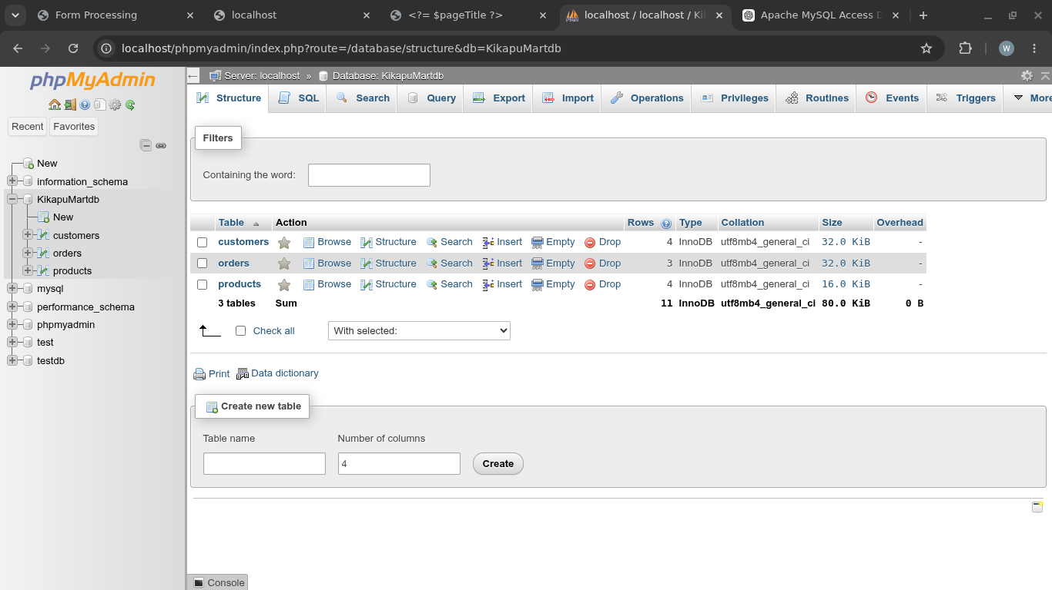Figure 14: Database Screenshot

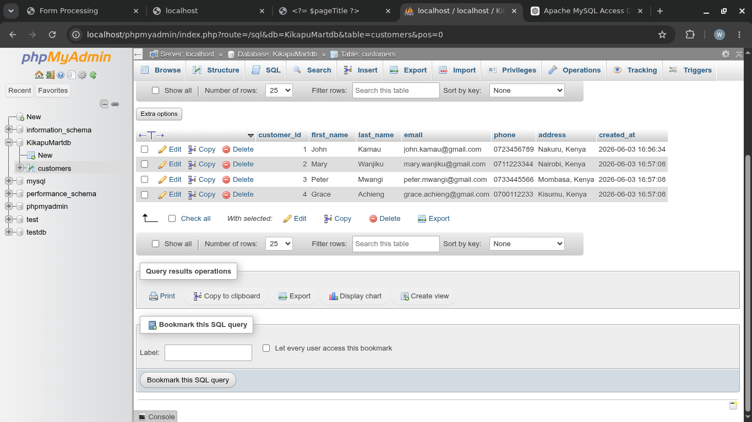Figure 15: Table Creation Screenshot

CRUD Operations and SQL Query

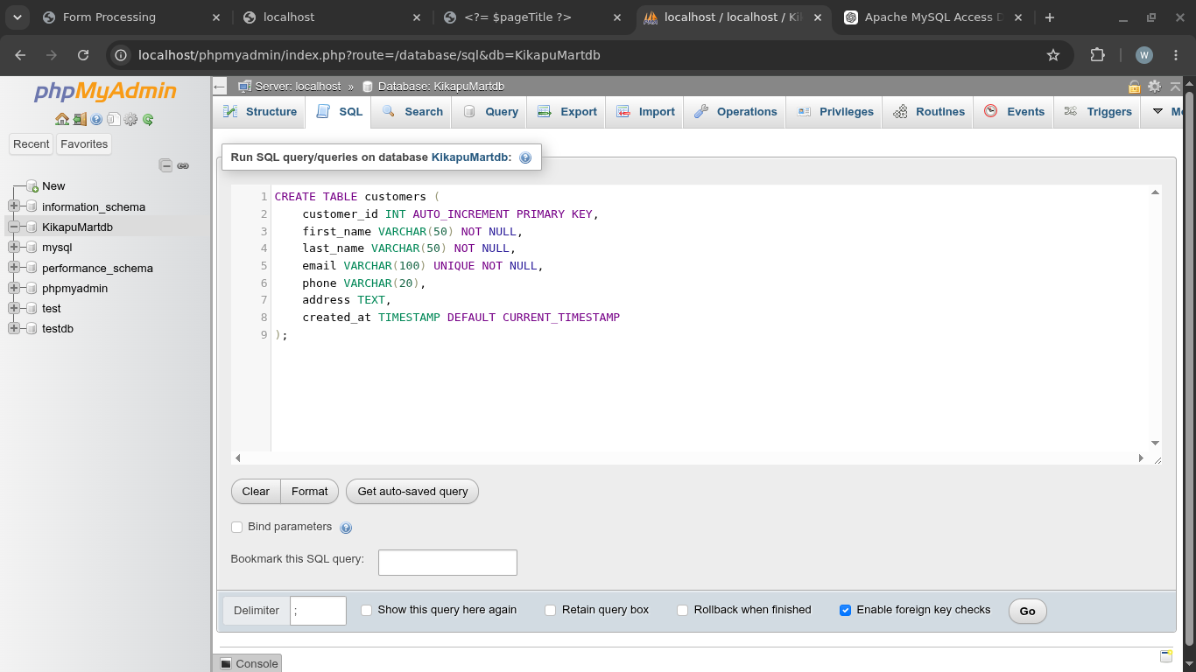Figure 16: Create Operation
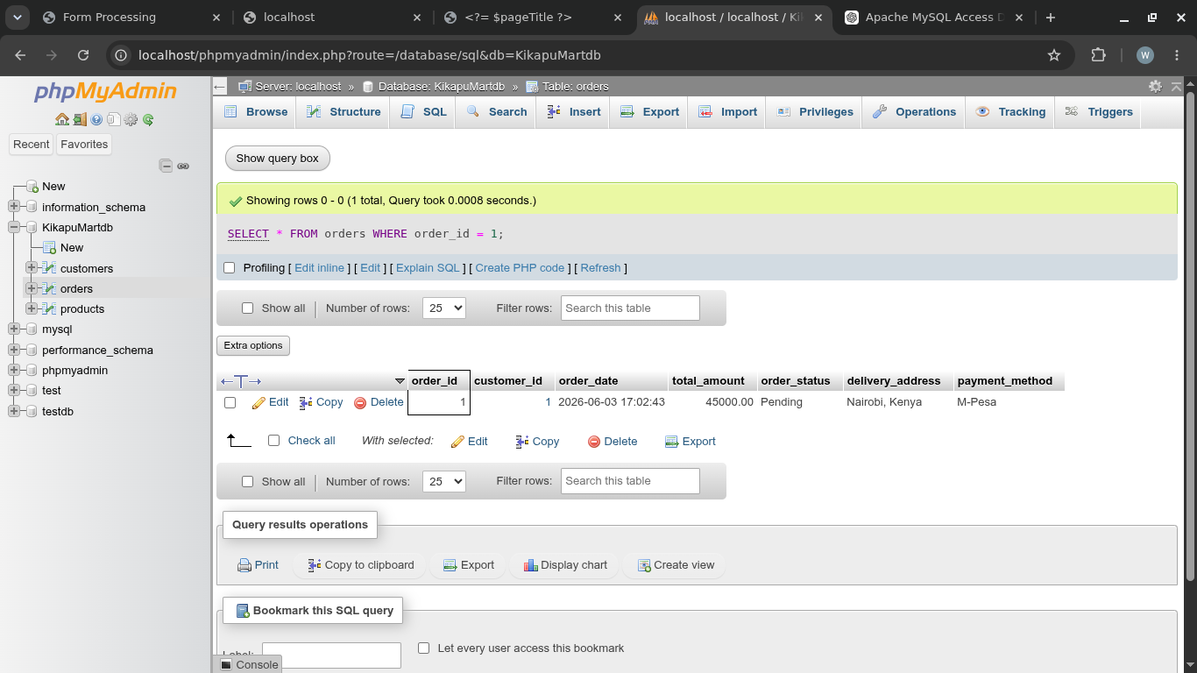Figure 17: Read Operation
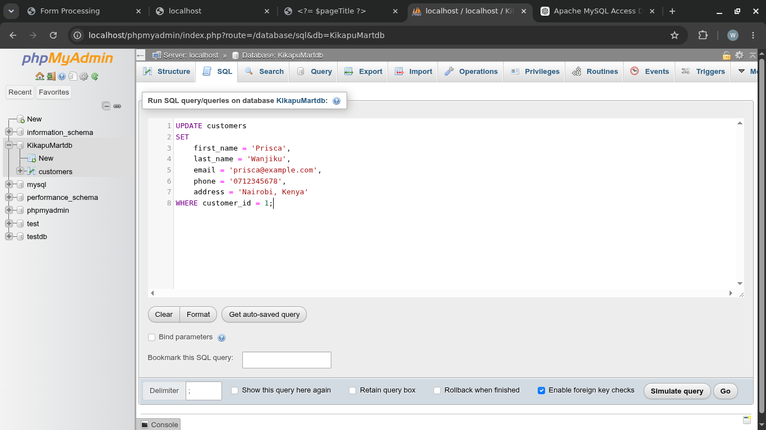Figure 18: Update Operation
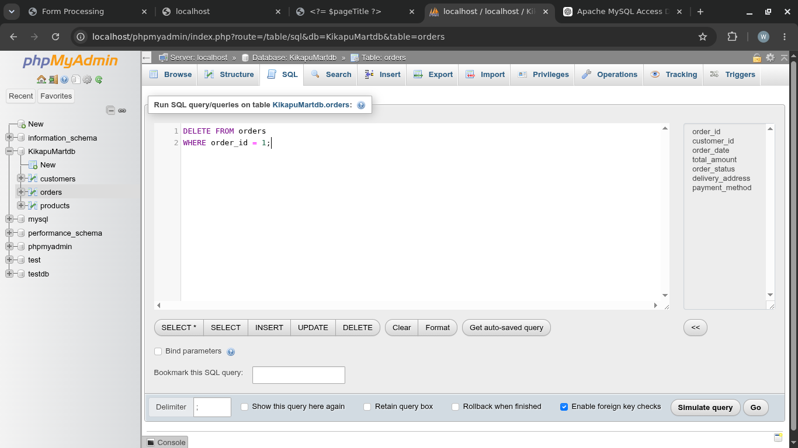Figure 19: Delete Operation
Reflection:
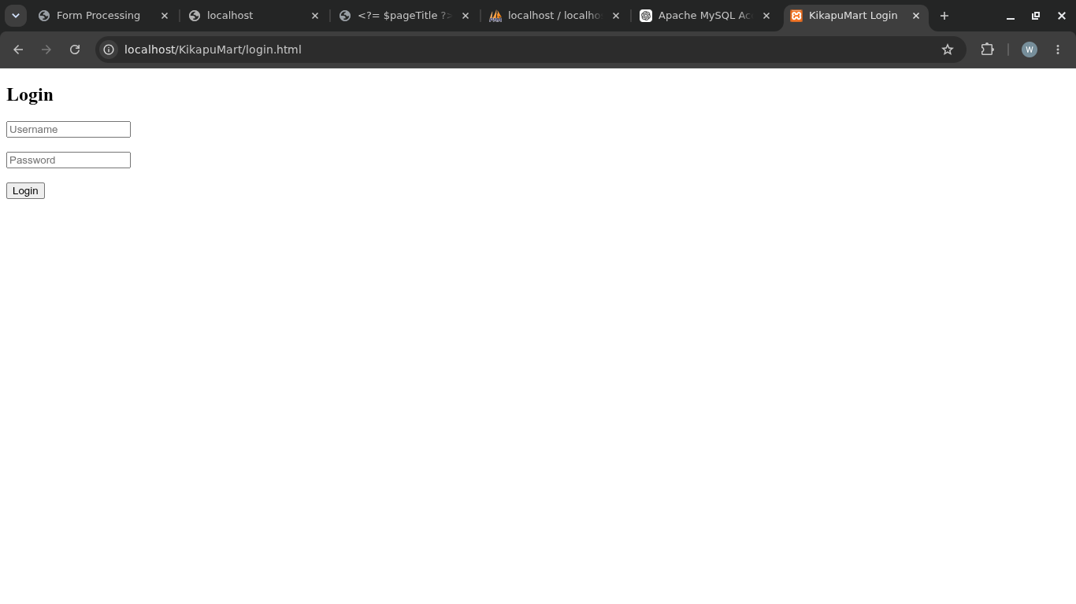Figure 20: Login Database Integration
- Fig.14:Shows the structural overview of the database named KikapuMartdb hosted on a local MySQL server.
- Fig.15:Shows the actual rows inside the “Customers” table, displaying records for users along with their contact information and creation dates.
- Fig.16:Displays the SQL text editor executing a “CREATE TABLE” command to establish the “Customers” schema, defining exact parameters for fields like IDs, names, unique emails, phone numbers, addresses, and automated timestamps.
- Fig.17:Displays successful execution of a retrieval query capturing a clean table output containing row parameters.
- Fig.18:Shows an data-modification query altering customer data fields for a specific record
- Fig.19:Highlights a specific data removal query inside the SQL editor to target and drop records safely from the system.
- Fig.20:Shows the fundamental frontend landing component under the local project path. It provides basic text input elements for usernames and passwords that directly tie into backend SQL search lookups for live production testing.

Week 6: Database Integration and CRUD Operations

Practical Task 1: Student Management System

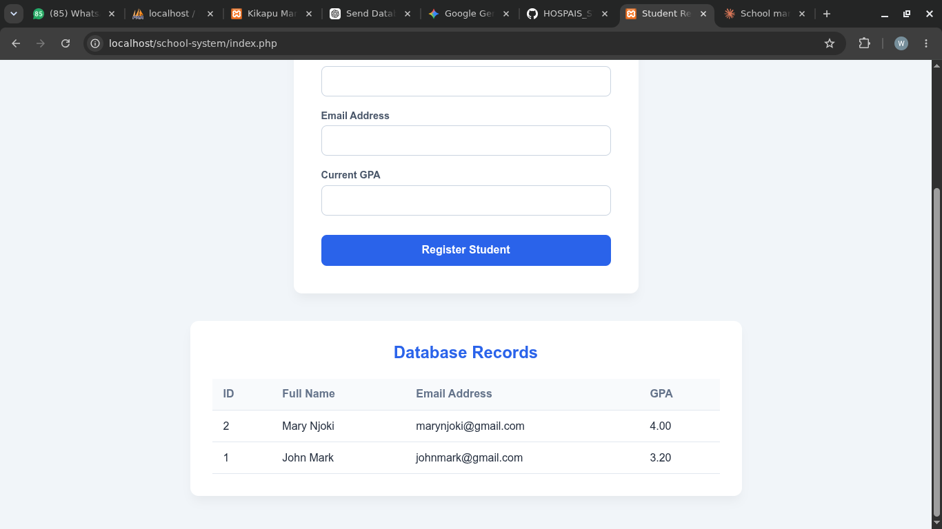Figure 21: Student Registration Page

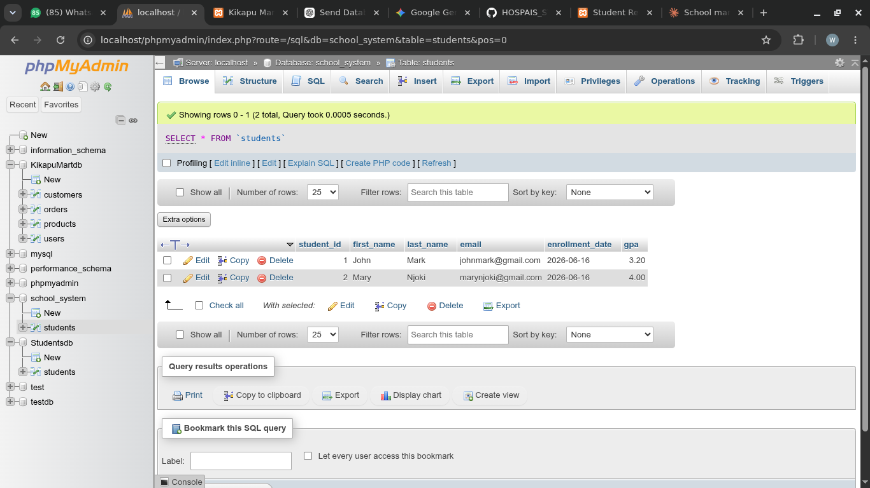Figure 22: Student Database
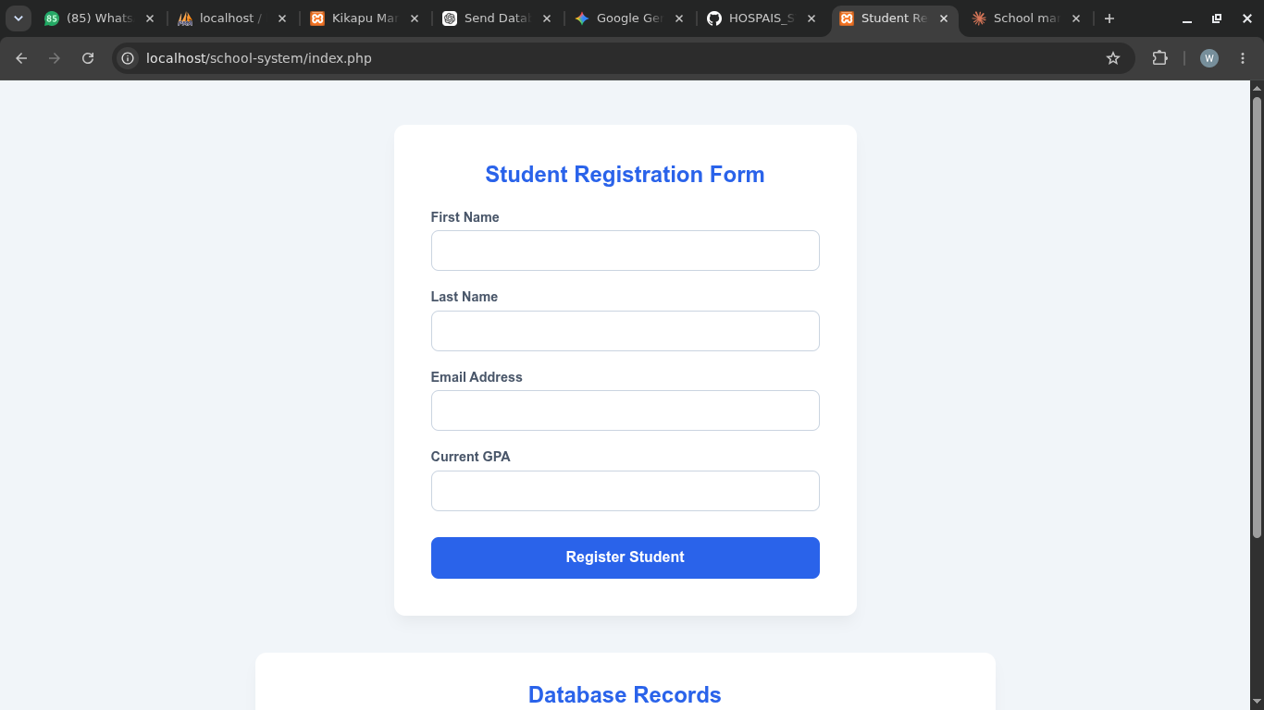Figure 23: Student Registration Form

Reflection:
Fig.21: It shows what happens after a student’s information is keyed in for registration. The information appears below after registration.
Fig.22: The student database indicates that the information entered at registration is stored in that particular database just the way it was keyed in.
Fig.23: It shows the structure of the student registration form and the information that is required for registration.

Practical Task 2: Library Management System

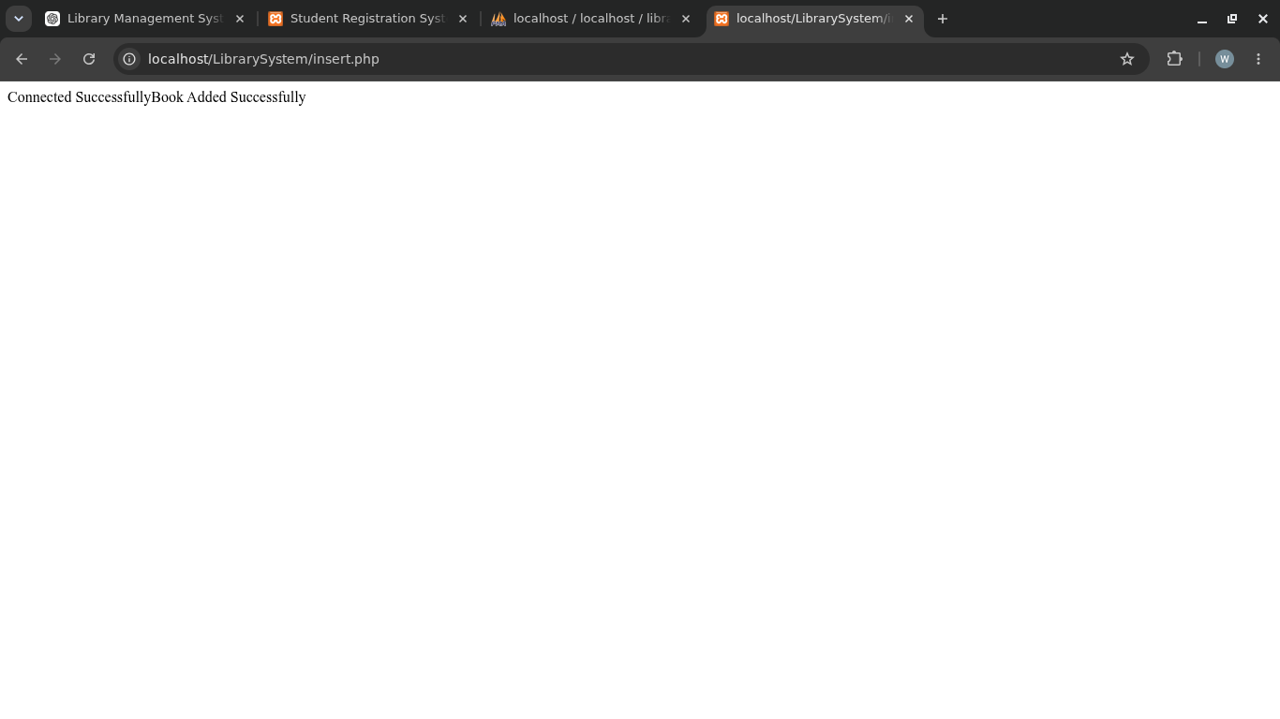Figure 24: Book Added Successfully

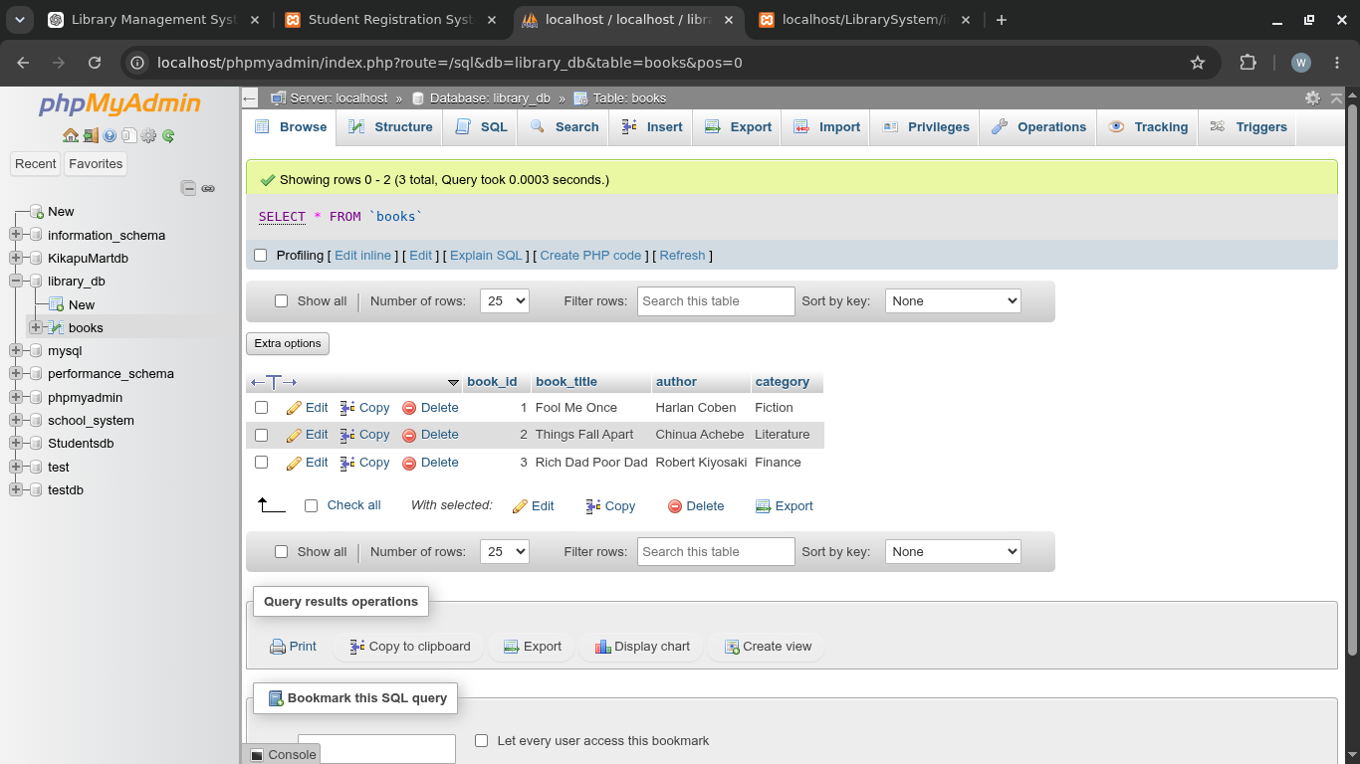Figure 25: Library Database

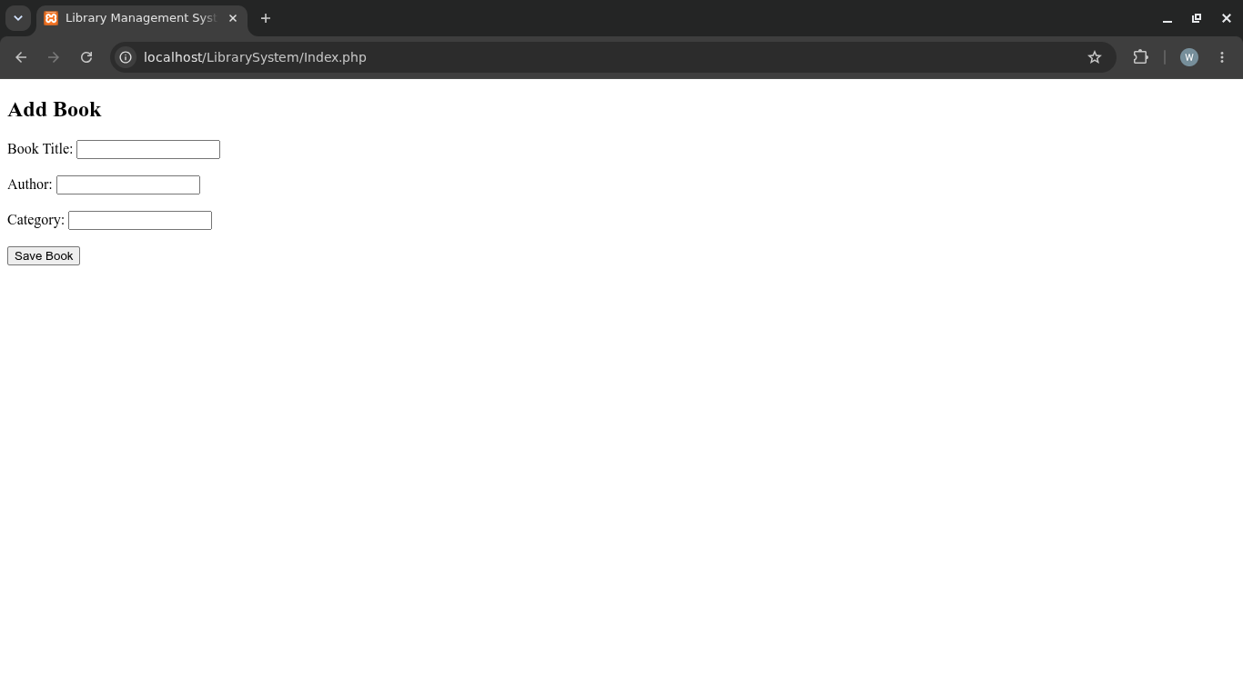Figure 26: Library Form

Reflection:
Fig.24: It shows that book information was keyed in successfully and it was recorded in the database.
Fig.25: It shows the structure of the database. It shows the books that have been recorded and the information stored.
Fig.26: It shows the front page where the administrator would key in the details of a book so that it can be recorded.

Practical Task 3: Employee Management System

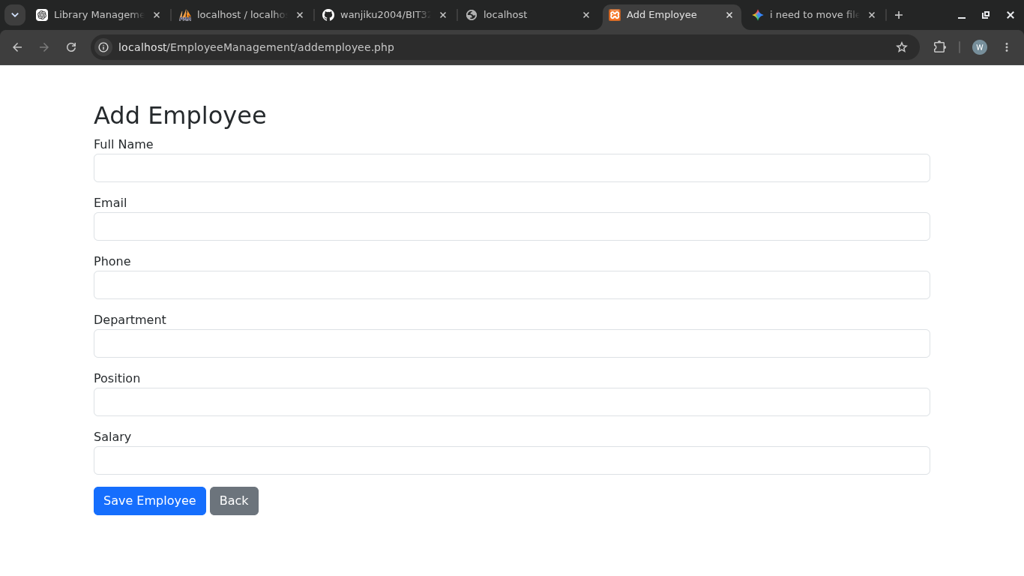Figure 27: Add Employee Page

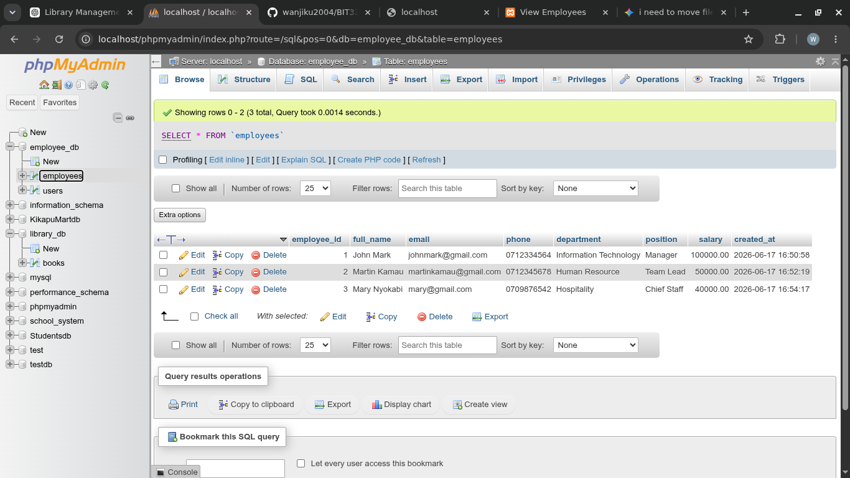Figure 28: Employee Database
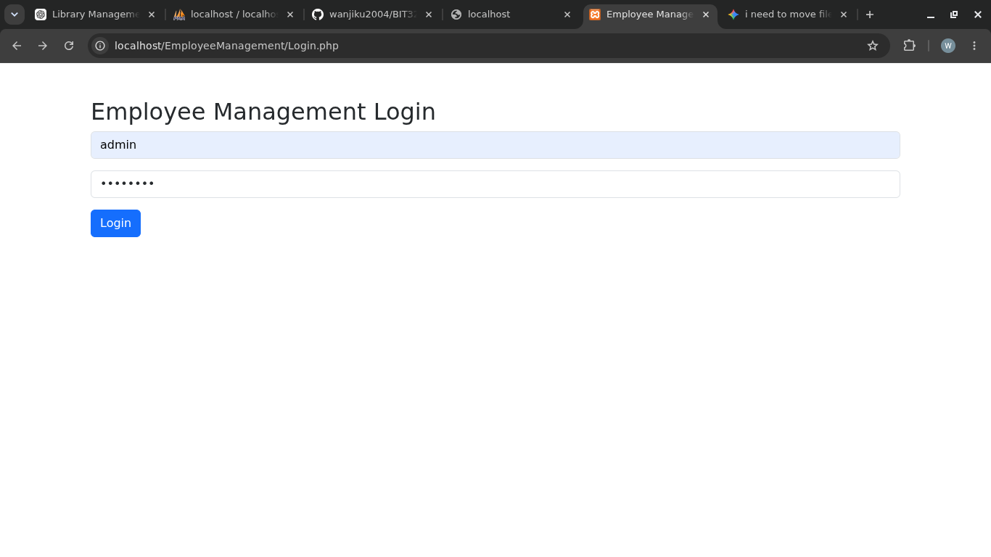Figure 29: Administrator Login Page

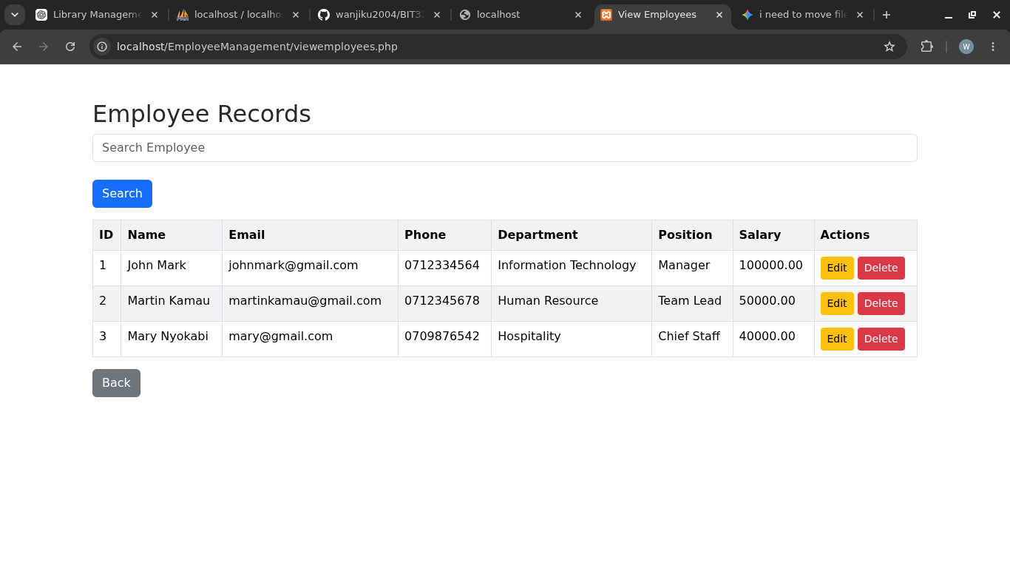Figure 30: Employee Records Page
Reflection:
Fig.27: It shows the “Add Employee Page” where the administrator is to key in all the relevant information on the employees for recording.
Fig.28: It shows the employee database where the information keyed in has been stored.
Fig.29: It shows the management login where the administrator keys in their information to access all employee records.
Fig.30: It shows the employee records and other functions like add or delete employee information. There is also a function provided where employee information can be searched and retrieved.

